US97 Facility Plan
(South Redmond Corridor Project)

Staff Report
Date: 18 November, 2021

Requested Action: Approve amending the Oregon Highway Plan (OHP) to adopt the US97 Facility Plan (South Redmond Corridor Project) along with associated Alternative Mobility Targets, and Findings of Consistency.

Background and Purpose
The purpose of the US97 Facility Plan (South Redmond Corridor Project) (Plan) is to provide a brief history of the planning process along the US97 SRC; describe the existing conditions found along the corridor, including economic and traffic conditions; outline the planning and decision making process, including a description of all concepts considered and evaluated; and finally, present the recommended concept for improvements along the corridor.
The Plan is intended to help address existing shortcomings of the current corridor, including:
    - Lacking or substandard pedestrian facilities.
    - Lacking or substandard bicycle facilities.
    - Limited crossing opportunities of US97 for pedestrians and bicyclists.
    - Limited east-west connectivity between the corridor and the neighborhoods to the west.
    - Untapped development potential due to a multitude of vacant or underdeveloped parcels along the corridor.
    - Challenging corridor aesthetics, dominated by automobile-serving facilities (roadways, driveways, parking) and auto-oriented businesses with associated signage.
    - The project is intended to provide improvements to maximize the function of US97 and the connecting transportation system by addressing traffic mobility safety, and local development needs.
    - The project will also provide the opportunity to enhance economic development, community urban design, and business vitality along the corridor.
    - Travel times along US97 are also improved with the recommended concept, with a 28 percent improvement in the northbound travel time and a six percent improvement in the southbound travel time compared to No Build.
    - If no improvements are made within the US97 corridor, crashes are predicted to increase from approximately 43 per year today to 76 per year by 2040.

The recommended concept described below addresses these shortcomings and includes benefits that range from operational and safety improvements to access improvements and aesthetic enhancements. Proposed improvements include:
    - Three new signalized intersections along US97 that provide protected U-turns.
    - Three new road connections that cross the canal and connect US97 to Redmond neighborhoods on the west side of US97.
    - Traffic separators between the northbound and southbound lanes on US97 that allow protected left-hand turning movements and U-turns at signalized intersections.
      - Areas for safe pedestrian refuge halfway across US97 to enhance pedestrian crossings.
      - New sidewalks and cycle track treatments throughout the length of the corridor and along east/west connecting roads to provide a more well connected active transportation network.
      - Connections to the new, already planned, shared-use path along Canal Boulevard and the canal.
      - A limited number of new access roads or alleyways to provide alternative access where new connections provide safe ingress and egress nearby.
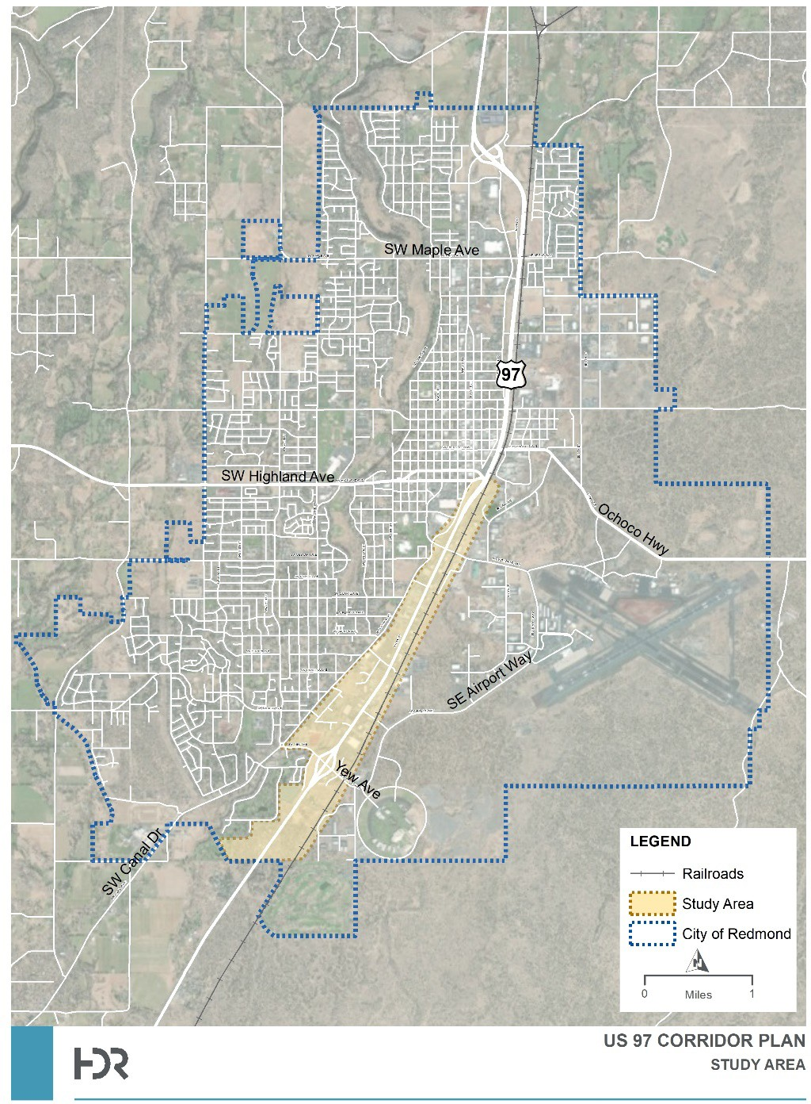
Plan Study Area

Recommended Design Concept
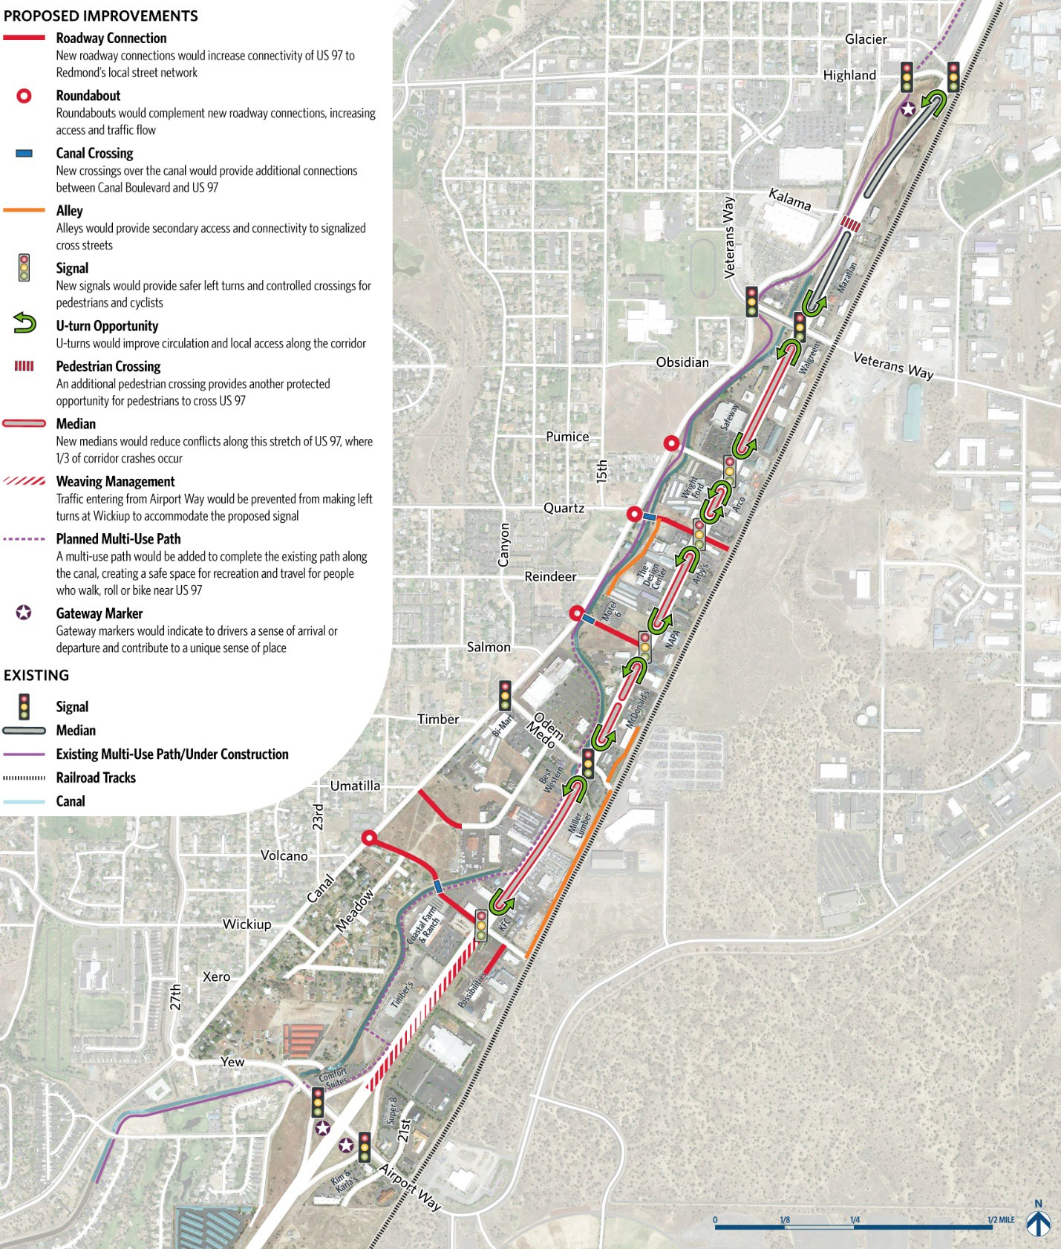
PUBLIC INVOLVEMENT AND LOCAL GOVERNMENT PARTICIPATION
As outlined in the Plan’s Public Involvement Memorandum, the purpose of public involvement in this project was to fully understand stakeholder issues in regards to the US97 SRC. It also sought to engage stakeholders in alternative evaluations, development, and selection of the project design.
Prior to reaching out to stakeholders about the project, the team developed key messages and identified crucial stakeholders who would be most interested in and impacted by this project. Coordinating with business and property owners along the corridor was crucial, so much of the project’s outreach was targeted to these stakeholders. Other key stakeholders included nearby residents, the City of Redmond, Deschutes County, the freight community, as well as multimodal users and general highway users. Identifying key stakeholders early on helped inform the formation of the Stakeholder Advisory Committee (SAC).
The SAC met five times throughout the project to discuss the goals of the process, approve evaluation criteria, and evaluate potential alternatives. In forming the SAC, the project team ensured that a variety of interests were represented, from business owners and managers to planners to influential members of the community. Business and property owners made up a large part of this group, as they would directly benefit from or be impacted by changes to US97 SRC in the short and long term.

Public Involvement Opportunities
The project team utilized a variety of tools to inform and seek input from the public, including:
Project Website. A website (www.southredmond97.org) was developed to provide information to the public about the purpose and background of the project and potential concepts for improvements. The site encouraged feedback on potential concepts through a comment form, as well as contact information for project team members. It also provided up-to-date information about upcoming events and ways to participate in the project.
Open House. On February 7, 2018, the project hosted an open house in partnership with the City of Redmond’s TSP. The US97 SRC station was attended by 16 people. To notify the public about the open house in
February 2018, an invite to the open house was included in the City’s newsletter. Input was provided from a broad part of the Redmond community. The need to improve US97 was a common comment at this event.
Business and Property Owner Site Sessions. Once potential design alternatives were identified, the project team organized two rounds of site sessions with business and property owners to discuss opportunities and concerns for each alternative. Site sessions were held at businesses along the corridor and were open to the public. Business and property owners were notified through a mailer for the first round and an email for the second round.
Mailers. To notify the public about the open house in February 2018, an invite to the open house was included in the City’s water bills prior to the event (Appendix G). Prior to the first round of site sessions in June 2018, a mailer was sent to business and property owners in the project area describing the project and inviting them to the site sessions and the upcoming Stakeholder Advisory Committee Meeting (Appendix H).
Fact Sheets. In February 2018 the project team developed a fact sheet describing the project, its purpose, and alternatives A and B, to be used for discussion at the site sessions as well as at the SAC, TAC and SC meetings (Appendix I). For the committee meetings in November 2018, the team created five fact sheets, one for each alternative (A, B, C, D and E), that describe the features of each alternative, as well as their potential benefits and impacts and how they scored against the evaluation criteria (Appendix J)
Stakeholder Interviews. In fall 2017, the project team conducted stakeholder interviews with a sampling of property owners, real estate professionals (brokers, developers), business owners, economic development officials, and adjacent neighborhood representatives (Appendix K). Twelve individuals were interviewed, and feedback received helped to inform evaluation criteria, initial design concepts, and public outreach efforts going forward.
Individual Site Sessions a few one on one interviews were conducted at business sites along the corridor:
- McDonalds: June 2018, visited site location and reviewed parking, driveway, and landscaping.
- Abby’s Pizza: June 2018, visited site location and reviewed design options, discussed parking, driveway, and landscaping.
- Madeline’s Grill: June 2018, visited site location and discussed sign location, landscaping, and driveway.
- Chevron: April 2019, visited site location and reviewed shared driveway alleyway behind the business and site circulation for freight trucks.
- Wilson’s Furniture: April 2019, visited site location and reviewed alleyway and backage road.
- BAS-X: April 2019; visited site location and discussed freight access and circulation.
Stakeholder Tracking. In spring of 2017, the project team contacted business owners throughout the corridor. This stakeholder tracking was used to send out mailing information about site sessions and project information. The map below identifies the properties whose owners engaged with the project team in green. The team didn’t hear back from owners of properties indicated in red although communication was provided to property and business owners.

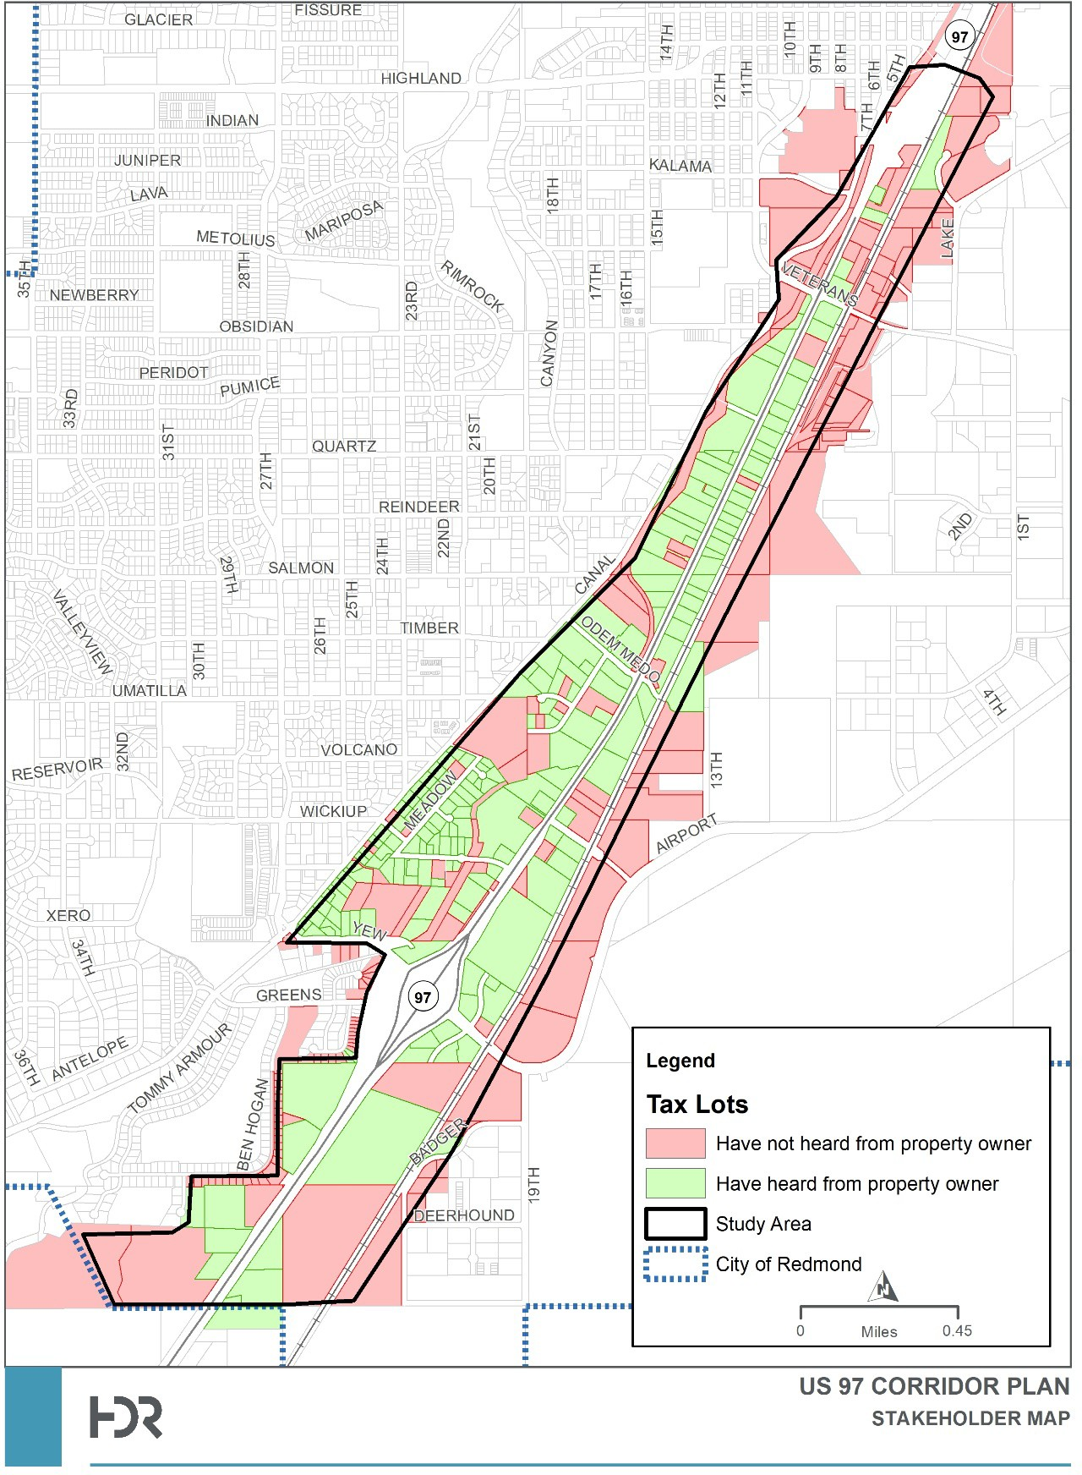
Stakeholder Tracking Map

Recommended Alternative Mobility Targets
Redmond adopted an update to its Transportation System Plan (TSP) in 2020. This TSP update met the technical and public involvement requirements outlined in the Transportation Planning Rule (TPR, Oregon Administrative Rule (OAR) 660-012). Further, the TSP includes a comprehensive set of policies aimed at encouraging future travel by pedestrians, cyclists and transit, and reducing vehicular travel. The TSP also includes a number of connectivity improvements aimed at reducing reliance on the state highway system for local travel.
The traffic operations analysis prepared for the TSP indicate that, even when the priority projects and policies described in the plan are constructed and implemented (in the future), there are several locations (intersections) where it will not be feasible to meet the prescribed ODOT mobility targets contained in the OHP. The TSP, by inclusion of the US97 Redmond South Corridor Facility Plan, recommends establishing alternative mobility targets at the eight locations addressed AMT memorandum.
ODOT and the City desire to establish a consistent corridor vision and set of transportation corridor changes (as identified through the US97 South Corridor Plan) along US97 between Veteran’s Way and the Yew Avenue interchanges. Providing a corridor-specific alternative mobility target that is consistent for each of these intersections, helps to achieve this goal. The corridor alternative mobility target is equal to a volume- to-capacity ratio of 1.0 with a peak hour factor (PHF) of 1.0 during Average Weekday Conditions.
The Redmond TSP was developed with significant input from the public and in collaboration with other jurisdictions and agencies, including Deschutes County, Central Eastside Transit, and ODOT.
The TSP includes policies and priority projects that reflect the City’s commitment to developing a balanced, multimodal transportation system, supporting continued economic development, supporting the Oregon Resiliency Plan, and improving the quality of the City and the region.
The request for the alternative mobility targets reflects agency partnerships that were strengthened during the TSP efforts and will continue through implementation. The request for these targets is not entered into lightly by any of the affected agencies but reflects support of ODOT, regional and city priorities as well as more sustainable transportation system with a tremendous focus on multimodal travelers of all ages and abilities. The alternative mobility targets described in this memo support these policies. Accordingly, the City of Redmond and ODOT request that the OTC amend the Oregon Highway Plan (OHP), by adopting the alternative mobility targets for the following intersections:
    - US97/SW Veteran’s Way;
    - US97/SW Pumice Avenue;
    - US97/Quartz Street;
    - US97/Reindeer Avenue/Salmon Avenue;
    - US97/Odem Medo Way;
    - US97 Northbound Ramp Terminal/Yew Avenue;
    - US97 Southbound Ramp Terminal/Yew Avenue; and,
    - US97/Wickiup Avenue.
To enable a consistent corridor vision, set of transportation changes and corridor management, the City of Redmond and ODOT Region 4 recommend establishing an alternative mobility target that is consistent for these eight corridor intersections. This alternative mobility target is equal to a volume-to-capacity ratio of 1.0 with a peak hour factor (PHF) of 1.0 during Average Weekday Conditions

